Group Project

GROUP 1

Naveen Sengamalam

Jang Ya-Jwu

Data Analytics

INFO8677 - Spring 2025 - Section 2

Prof: Kanika Khatter

Due Date: Aug 05, 2025

Table of Contents
1. Introduction: 3
Key questions we explore in this report include: 3
2. Data source: 4
Metadata and Attributes: 4
Input Variables 4
Derived Variables 4
3. Data Exploration 5
Insight 1: Divergent Trends in Nurse-to-Doctor Ratios (2010-2020) 5
Insight 2: Regional Disparity in Nurse-to-Doctor Ratios 5
Insight 3: TOP 5 countries by Nurse-to-Doctor Ratios 6
Insight 4: Doctors and nurses in Canada (2018-2023) 7
Insight 5: Correlation Between Doctors and Nurses (2023) 8
4. Recommendations 9
Appendix A: Dashboard 10
Appendix B: Python Code on Anaconda Jupyter 10
Team Contributions: 13
References: 14

1. Introduction:
This report takes a closer look at how the global healthcare workforce has changed over the past decade—specifically focusing on the numbers and balance between doctors and nurses from 2010 to 2023. Using real-world data from the World Health Organization’s (WHO) Global Health Observatory, we explore how the availability of healthcare professionals varies across regions, with a special focus on Canada.
The goal of this analysis is to better understand whether countries are facing imbalances or achieving coordination between doctors and nurses, using the nurse-to-doctor ratio as a key indicator. Through a combination of visual dashboards and data-driven analysis, we aim to highlight patterns, track changes, and provide context for how different regions manage their healthcare workforce.

Key questions we explore in this report include:
- How has the nurse-to-doctor ratio shifted over time in different parts of the world?
- Where are the biggest gaps or disparities in healthcare staffing?
- What do the numbers look like in Canada specifically between 2018 and 2023?
- Is there a global pattern or correlation between the number of doctors and nurses?
This kind of analysis can be incredibly useful for healthcare policy makers, public health leaders, and workforce planners. It sheds light on both the successes and ongoing challenges in developing a balanced, well-supported healthcare system.

2. Data source:
The datasets were retrieved from the WHO Global Health Observatory (GHO) data portal for the National Health Workforce Accounts (NHWA).
- Source Link: https://www.who.int/data/gho/data/themes/topics/health-workforce

Metadata and Attributes:
The dataset has two primary files, data-doctor.csv and data-nurse.csv, with the same attribute structure but for different indicators.

Input Variables
- Location: The name of the country (e.g., "Niger", "Chad", "Norway").
- ParentLocation: The geographical region to which the country is in (e.g., "Africa", "Europe", "Americas").
- Period: The year the data corresponds (e.g., 2023, 2022, 1980).
- Indicator: A categorical variable describing the data.
  - In data-doctor.csv, the indicator is Medical doctors (per 10,000).
  - In data-nurse.csv, the indicator is Nursing and midwifery personnel (per 10,000).
- Value: A numerical variable representing the number of doctors or nurses per 10,000 people.

Derived Variables
- Nurse_to_Doctor_Ratio: This variable is calculated by merging the data-doctor.csv and data-nurse.csv datasets. It represents the nurse-to-doctor ratio in every country and is one of the primary variables of analysis.

3. Data Exploration

Insight 1: Divergent Trends in Nurse-to-Doctor Ratios (2010-2020)
Analysis Goal: To track the nurse-to-physician ratio over a decade (2010 to 2020) among the most and least balanced staffed healthcare countries.
Expected Findings:
- Growing Imbalance: Countries with a high nurse-to-doctor ratio in Southeast Asia or sub-Saharan Africa are most likely to have stable or increasing trends. In other words, the disparity of the nurse-doctor ratio in these countries human resources is not improving and is likely worsening, indicating growing dependency on nurses.
- Converging Ratios: Alternatively, the countries with a low starting ratio (e.g., in North America or Europe) can have an extremely stable or slowly increasing trend.
- Policy Implications: The chart will visually show which countries or regions have successful interventions in balancing their medical professional staff and which are unsuccessful. The slope of the lines will be a measure of the rate of change, or absence of, in different national healthcare systems.

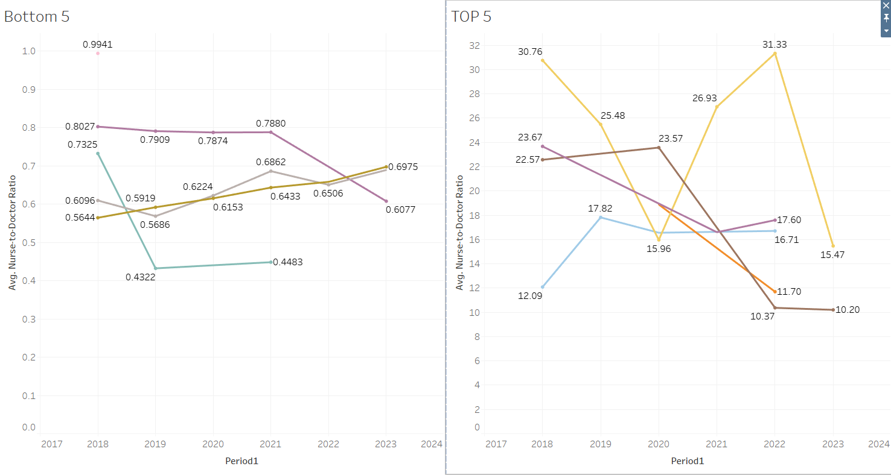

Insight 2: Regional Disparity in Nurse-to-Doctor Ratios
Analysis Goal: To compare the average nurse-to-doctor ratio across the six large geographical regions. This provides an overall picture of worldwide distribution of health workers.
Expected Findings:
- Significant Regional Gap: The most impressive finding will be the extensive gap in the average ratio between regions. The average ratio for the African region (AFR) must be significantly higher than for Europe (EUR) or the Americas (AMR).
- Geographic Correlation: The visualization will confirm the notion that the imbalance in workforce is not dispersed randomly but is concentrated geographically. The bar heights will show an evident inverse correlation between a region's level of economic development and the average nurse-to-doctor ratio.
- Health System Maturity Indicator: An above-average ratio in a given area can't automatically be an indication of the lack of doctors but also of a greater dissimilarity in the type of healthcare being provided, with more of a role being played by nurses based on need. This bar chart will provide clear evidence for this, a powerful graphic representation of healthcare workforce disparities around the world.

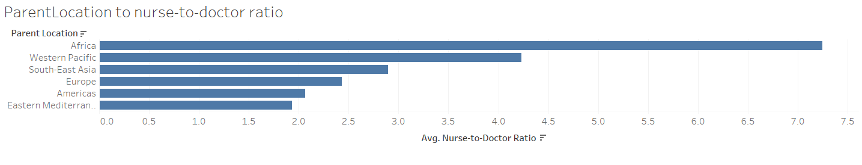

Insight 3: TOP 5 countries by Nurse-to-Doctor Ratios
Analysis Goal: To identify the countries with the highest Nurse-to-Doctor ratios and examine their geographical locations to determine if a strong regional pattern exists.
Expected Findings:
- The top 5 countries with the highest nurse-to-doctor ratios are geographically similar, which confirms the assumption that high ratios are exclusive to a single region like Africa. This means that the African region also supports the finding that many nations on the continent rely heavily on nurses.
- The list includes countries from the Eastern Mediterranean region (EMRO) and Africa.
- Oman ranks at 5 among the highest, indicating that a significant workforce imbalance can also be present in high-income nations.

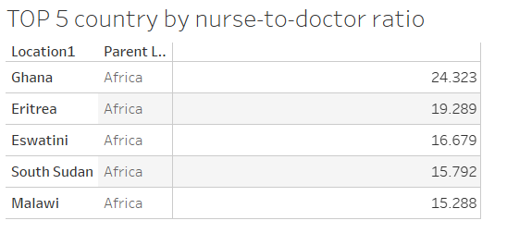

Insight 4: Doctors and nurses in Canada (2018-2023)
Analysis Goal: To examine the trends in the number of doctors and nurses in Canada over the period from 2018 to 2023, assessing changes in healthcare workforce distribution.
Expected Findings:
- Increasing Nurse Numbers: The number of nurses is expected to show a significant upward trend (e.g., from 59,949 in 2018 to 261,265 in 2023), reflecting a growing reliance on nursing staff, consistent with Insight 1’s prediction of slowly increasing nurse-to-doctor ratios in North America.
- Stable or Modest Doctor Growth: The number of doctors is anticipated to remain relatively stable or increase modestly (e.g., from 188,152 in 2018 to 192,496 in 2023), indicating a slower growth rate compared to nurses.
- Policy Impact: The data may suggest successful healthcare policies aimed at expanding nursing roles, aligning with Insight 2’s indicator of health system maturity, where higher nurse numbers reflect adaptive workforce strategies.
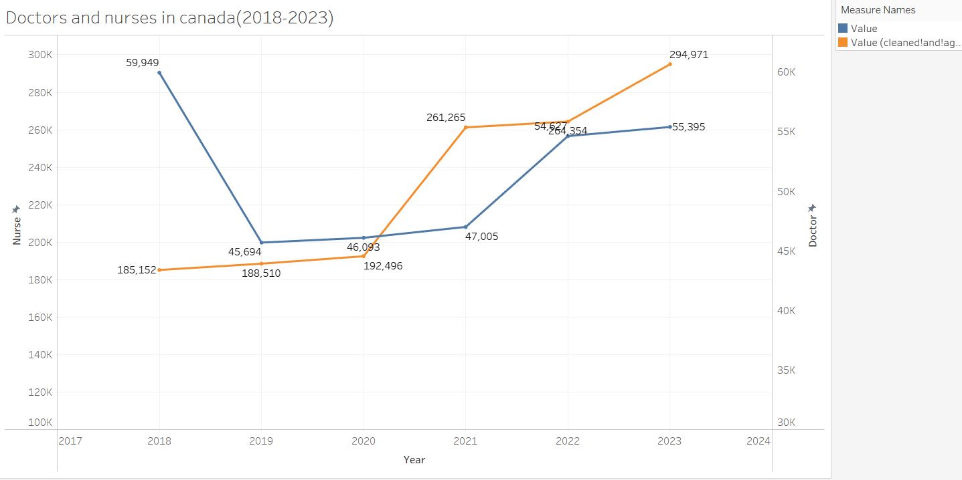

Insight 5: Correlation Between Doctors and Nurses (2023)
Analysis Goal: To investigate the relationship between the number of doctors and nurses across various countries, including Canada, in 2023, to identify patterns in healthcare workforce balance.
Expected Findings:
- Positive Correlation: A strong positive correlation is expected between doctor and nurse numbers (e.g., 192,496 doctors and 261,265 nurses in Canada), supporting Insight 2’s geographic correlation where economically developed regions show balanced staffing.
- Regional Variations: Countries with fewer doctors (e.g., Ghana with 24,323) are likely to have proportionally fewer nurses (e.g., 19,289), while developed nations like Canada exhibit higher numbers, reflecting Insight 1’s converging ratios in stable healthcare systems.
- Workforce Alignment: The scatter plot should highlight that higher doctor counts correlate with higher nurse counts, suggesting a global trend of coordinated healthcare staffing adjustments based on regional needs.
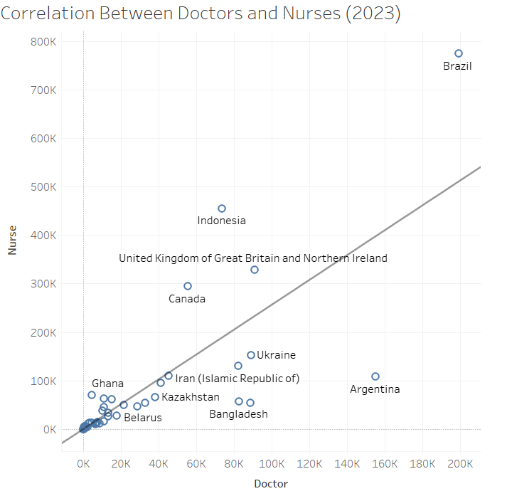

4. Recommendations

1. Targeted Investment in Doctor Training & Retention:
Prioritize doctor training and retention in high-ratio regions (e.g., Africa) to prevent brain drain.

2. Strategic Workforce Planning & Policy:
Implement data-driven national workforce plans for balanced doctor and nurse growth, regularly monitoring ratios for adaptive policy.

3. Empower & Expand Nursing Roles:
Invest in advanced training and expanded responsibilities for nurses, optimizing their utilization in doctor-shortage areas.

4. Foster Global & Regional Collaboration:
Encourage international partnerships and standardized data collection for robust comparative analysis and effective policy-making.

Appendix A: Dashboard

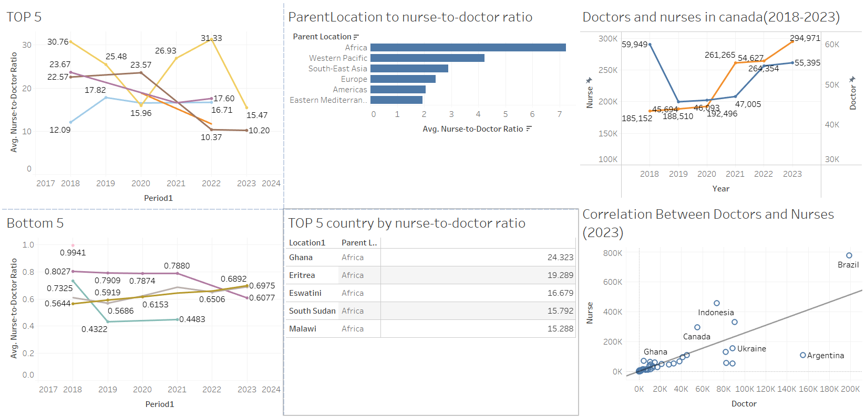

Appendix B: Python Code on Anaconda Jupyter
- Obtain the total number of countries in the two datasets
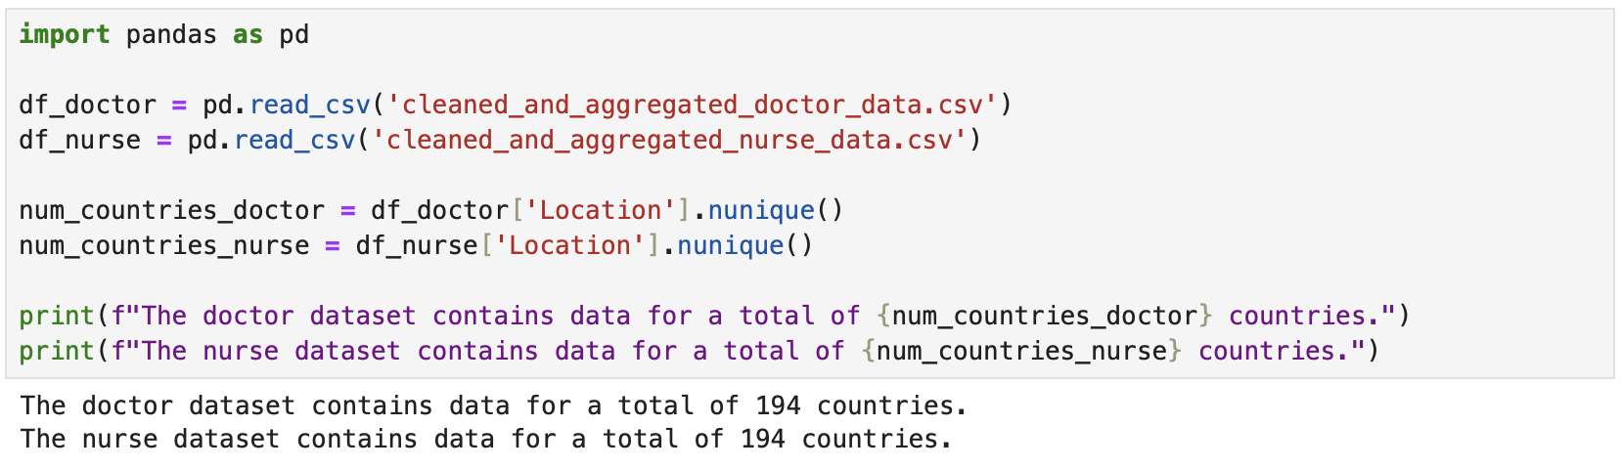

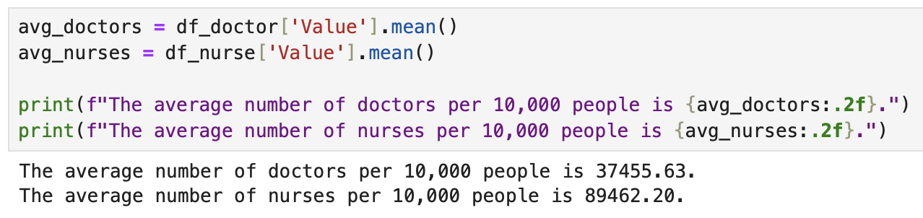
- Obtain the average number of doctors and nurses per 10,000 people
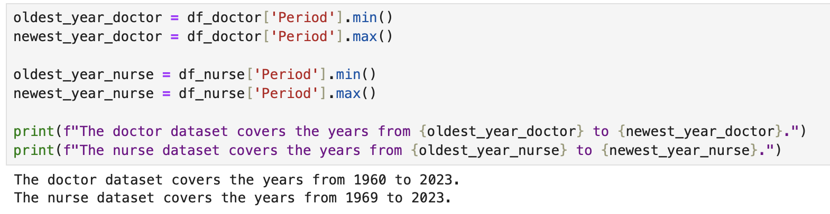
- Obtain the period of years in the two datasets

- The Parent Location with the highest nurse-to-doctor ratio is Africa

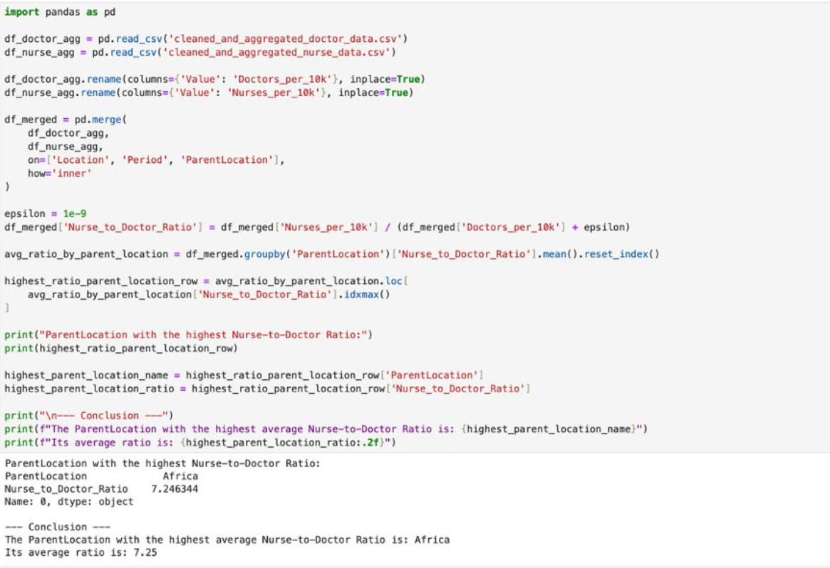

5. Obtain the data for Canada
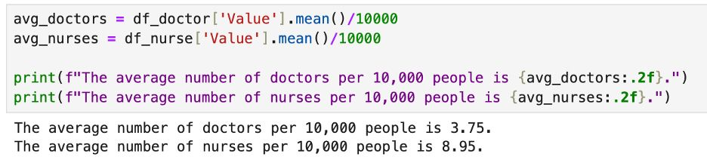

Team Contributions:

Jang Ya-Jwu | Clean data, retrieve data or data source  2 Insights  Python  PPT(Presentation)
Naveen Sengamalam | 3 Insights  Dashboard  Report  Presentation

References:
SlidesGo. (n.d). Animated Healthcare Center. Retrieved from SlidesGo: https://slidesgo.com/medical
WHO. (2023). Global Health Workforce statistics database. Retrieved from WHO: https://www.who.int/data/gho/data/themes/topics/health-workforce

